BOOKING FORM

Please pay by bank transfer to Wirksworth Community Choir
Acc No. 80615732 sort code 60-14-15
Ref: Brahms and your name

Email Pamela to indicate your voice part and whether you need a score. pamelajames5@hotmail.co.uk

Or
Send with a cheque made payable to Wirksworth Community Choir

Post or deliver to Pamela James 40 St. John’s Street. Wirksworth. DE4 4DS

Name……………………………….…………

Address………………………………………………………………….

……………………………………………………………………………..

Post Code………………....Telephone……………………………..……

Email……………………………………………………

Please indicate: Soprano Alto Tenor Bass

Do you need a score?

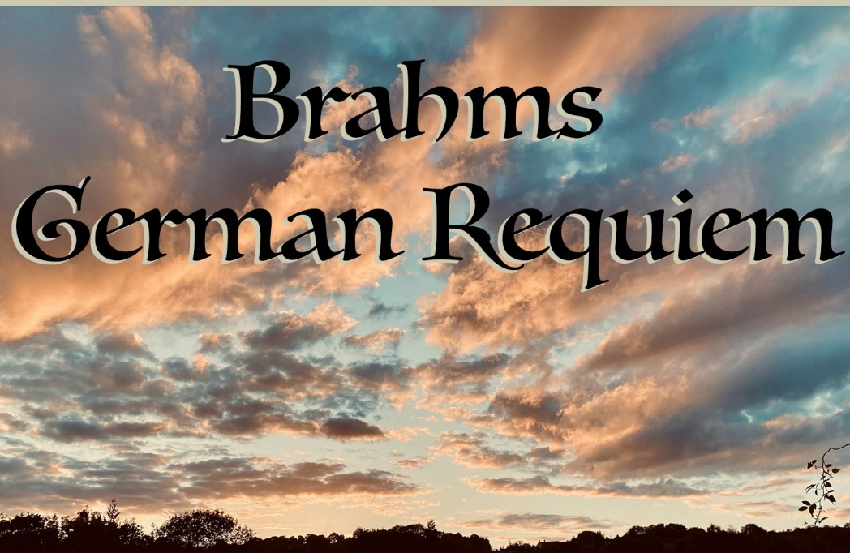

You are invited to join

Wirksworth Community Choir

for a COME and SING day

followed by an informal performance

Adam Green will be leading the workshop Accompanied for the day by Tim Capes on the organ

The Workshop is at St Mary’s Church, Wirksworth on
Saturday 21st March 2026 from 10 am to 5 pm
Registration from 9.30am

ADAM GREEN
​Adam graduated from the University of Sheffield with a degree in Music and English and went on to gain his postgraduate degree in Education from the University of Nottingham.
​
​His musical experience has encompassed choral, brass and orchestral conducting; commissions for original compositions and arrangements; working in the education sector and as a private teacher.

TIM CAPES
Tim started learning the piano at the age of 7 and later added viola and violin. He enjoyed playing in various orchestral ensembles in and around Derby before moving to Rodsley.
It was here that Tim began to explore playing the pipe organ for church services and providing accompaniment for choirs and vocal ensembles.

WIRKSWORTH COMMUNITY CHOIR
Wirksworth Community Choir has been singing since the 1980s and is a friendly, mixed voice choir with around 25 members. The repertoire is wide ranging and varied. We are a choir for all occasions. New members are always welcome with no audition needed.

REHEARSAL CDs and DOWNLOADS
You will be able to download the music from websites such as:

www.chordperfect.com

Or try YouTube for performances. www.youtube.com

TO BOOK:
Pamela James 01629 826413 pamelajames5@hotmail.co.uk

REFRESHMENTS/LUNCH
Hot and cold drinks will be provided as you register in the morning and during the day and we will be serving tea and homemade cakes in the afternoon. There are options for lunch in town or bring a packed lunch. The church will also be open all day so you can keep warm.

MUSIC SCORES

These will be available on the day if you need a copy we will be using the Novello Edition

INFORMAL PERFORMANCE
This takes place in St Mary’s Church, Wirksworth at 5pm and will last about one hour Tickets £5 on the door. Although we have no dress code, wearing darker clothes adds some formality to our performance.

CHARGES

Workshop fee £20
Students £10
In addition to the Choral Day, you are warmly invited to come to the weekly choir rehearsals as we learn this wonderful music. These rehearsals will take place at 7.45pm at Wirksworth Junior School, Wash Green, DE4 4FD on March 4th, 11th and 18th

The scores will be available. We would ask for £4.50 per session to help with choir expenses.

